Art and Design
We will:
Create mosaics with a contrasting border
- Exploring our ideas and recording our experiences in our sketch books, reviewing and revisiting our ideas
- Become proficient in the use of a printing technique to produce a mosaic effect
- Evaluate and analyse our work
- Understand the historical and cultural significance of Roman mosaics.
Design and make Roman style purses and shields
- Exploring our ideas and recording our experiences
- Evaluate and analyse our work

Create and follow a recipe to make Roman bread using herbs and traditional ingredients.
- Know and understand the rules of basic kitchen safety
- Evaluate and analyse our finished product

History
We will:
- H4.10 Know what A.D. means and that it can also be referred to as C.E.
- H4.11 Know how to plot events on a timeline accurately using A.D./C.E. and B.C./B/C.E.
- H4.14 Know the key events within Roman history and society up to the fall of the Roman Empire and track these on a timeline.

- H4.13 Know the key events in Boudicca’s life leading up to her rebellion and death and track these on a timeline.
- H4.3 Know how there was British resistance to the Roman occupation.

- H4.2 Know when and how the Romans invaded
- H4.1 Know the Iron age ended with Roman invasion by AD42

- H4.12 Know how Britain changed from the Iron Age to the end of the Roman occupation
- H4.4 Know how the Roman Empire impacted British society

- H4.16 Know and make links between two overlapping periods of history, The Egyptians and the Romans
When in Rome …
Year 3 and 4 Topic Web – Spring Term 1- 2022
English
Our Class Books: Aquila By Andrew Norriss
Horrible Histories: The Ruthless Romans By Terry Deary
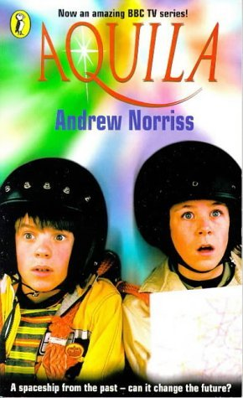
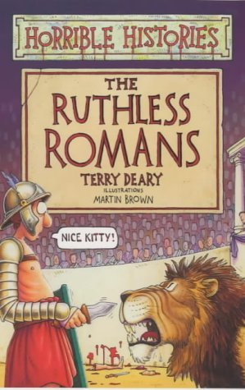

We will:
- Invite our adults into school to view our Roman displays, books, homework and artwork
- Invite our adults into school to take part in a Roman quiz and to taste our Roman cooking
- Hold a Roman day when we will dress up as Romans, take part in Roman soldier training, using our shields in formation and watch the ‘Rotten Romans’ Horrible Histories movie.
- Visit Bosworth Battlefield for a Roman-Themed school trip

nm

Geography
We will:
G3.7 Use maps to locate European countries and major cities involved in the Roman invasions
Use maps to locate Roman roads and their locations relative to major cities in the United Kingdom

English  Myths and Legends / stories with characters and settings. Persuasive speech  - Increase pupil’s familiarity with a wide range of books, including myths and legends, fiction from other cultures and traditions.  - Draft and write by: composing and progressively building a varied and rich vocabulary and an increasing range of sentence structures, organising paragraphs around a theme. Create settings, characters and plot.  - Write for a range of real purposes and audiences. | - Focus on the myth ‘Romulus and Remus’ – recognise and identify features of myths and legends.  - Work in groups to narrate and act out the story.  - Use inverted commas correctly in dialogue.  - Know what adverbs and adverbial phrases are and use fronted adverbials in their writing. Start sentences in varied ways.  - Know what an expanded noun phrase is and use them in their writing.  - Plan and write the story of Romulus and Remus and check and edit their writing.  - Plan and write their own myth/legend using the features of myths and legends to create their own setting, characters and plot.  - Recognise the features and structure of a persuasive speech. Identify and explore persuasive devices.  - Construct a persuasive speech, imagining they are Boudicca, using appropriate text structure, language features and devices.  - Learn and apply proofreading and editing skills.  - Present a persuasive speech to the class using appropriate oral presentation skills
Science  Living Things  - Sc4/2.1c recognise that environments can change and that this can sometimes pose dangers to living things.  Rocks  - Sc3/3.1b describe in simple terms how fossils are formed when things that have lived are trapped within rock | - Know that changes to the environment can make it more difficult for animals to survive and reproduce; in extreme cases this leads to extinction, where an entire species dies  - Know that human activity – such as climate change caused by pollution - can change the environment for many living things, endangering their existence  - Know that the polar bear is a famous example of climate change endangering the existence of a species; as the climate changes and gets warmer, the sea ice on which polar bears live reduces in amount making it harder for them to survive and reproduce  - Know that fossils form when a plant or animal dies and is quickly covered with silt or mud so that it cannot be rotted by microbes or eaten by scavenging animals; in time layers of sediment build, squashing the mud and turning it to stone around the dead plant or animal; the materials in the body are replaced by minerals that flow in water through the rock, leaving a rock in the shape of the animal or plant that was once there
Computing  We are time travellers – create an animation of Romulus and Remus. | - Explain what is meant by animation.  - Create a series of linked frames that can be played as a short animation.  - Control and adjust a time slider to locate a different point in a film clip.  - Insert images to create a simple stop motion animation short film clip.  - Add other types of media to their animation, such as music/text.
Other Areas of the Curriculum – not linked to the topic

Maths | We will learn how to multiply and divide 2-digit numbers by 1-digit numbers, using the formal method of short multiplication and partitioning for division to enable us to calculate outside of the times tables.  We will measure, compare, add and subtract lengths in mm, cm, m and km and measure and calculate the perimeter of simple 2D shapes. In Year 4 we will find the area of rectilinear shapes by counting squares.  We will learn to recognise and explain the similarities and difference between unit and non-unit fractions. We will use number lines to count up and down in fractions, including counting part 1 whole. We will learn to recognise and work with equivalent fractions, spotting patterns and calculating equivalent fractions using proportionality.
Religious Education – People of God - What is it like to follow God?  Understanding Christianity | - Learn about some of the people of the Old Testament (Noah and Abraham) and their covenant relationship/friendship with God.  - Find out how the people of God try to live in the way God wants, following his commands and worshipping him. They believe he promises to stay with them and Bible stories show how God keeps his promises.  - Recognise that the Old Testament narrative explains that the People of God are meant to show the benefits of having a relationship with God, and to attract all other nations to worshipping God.  - Understand that Christians believe that, through Jesus, all people can become the People of God.
French – Unit 3 Rigolo  - Mon corps (my body) | - Identify parts of the body  - Describe eyes and hair  - Recognise days of the week  - Give basic character descriptions
PSHE – Managing Change, Myself and My Relationships | - Identify changes that they and other children may experience in their lives.  - Be able to name emotions that may be involved in loss and change situations, and have some strategies for coping with them.  - Know what helps or hinders when they are experiencing difficult emotions, and how to ask for help.  - Be able to plan to make a chosen change happen.
P.E.  - Gymnastics  - Multi-skills | - Explore how to make 2-point balances and how to link their balances whilst doing a travelling action.  - Work in pairs and demonstrate travelling towards and away from each other by matching each other’s actions.  - Explore how to make different shapes, mainly tuck and pike shapes.  - Develop their balance, movement and shapes using the apparatus, including mats and benches.  - Learn a new technique called the Hurdle Jump which they will be using the springboards to demonstrate this technique.  - Develop balance and have a good understanding of different balance positions  - Maintain their control whilst moving in a certain way i.e., hopping and apply balance whilst frozen on the spot.  - Develop understanding of how to dribble using a basketball.  - Develop catching skills, with the focus on making a catch above and below the waist.  - Show good sportsmanship, fair play and respect by participating in mini games and activities whilst working as a team.
Music –Ukelele class lessons | - In this unit, children will work in small groups, composing rhythm patterns which are then practised with an emphasis on maintaining pulse. They will explore graphic and formal notation, using crotchets, quavers and rests and compare how these representations can look when placed side by side.

When in Rome…
Homework Tasks
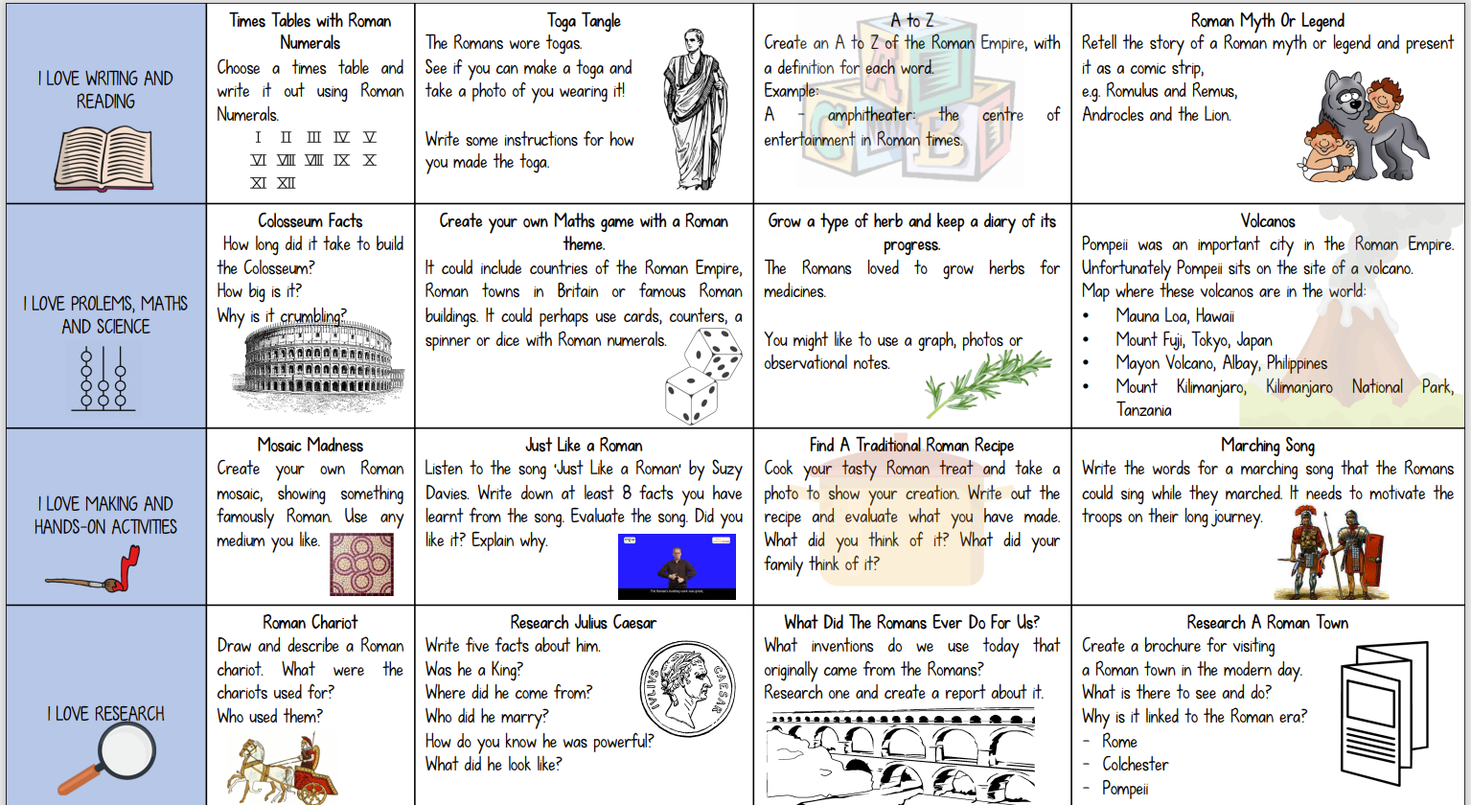

In your reading diary, it explains the expectations for homework with regards to reading, spelling and maths each week. In addition, I would like you complete one task every 2 weeks, these are linked to our topic. You are welcome to do more if you wish! You can hand the homework in as follows: by emailing it to class2@thrussington.leics.sch.uk; by submitting it on Teams or by physically bringing it in.

