History
National Curriculum Ref. Pupils should be taught to:
Carry out a local history study
a study over time tracing how several aspects of national history are reflected in the locality (this can go beyond 1066)
a study of an aspect of history or a site dating from a period beyond 1066 that is significant in the locality.
In this Unit, we will:
-carry out a study of our local area using secondary sources: the census, school log-books, church or graveyard records, photographs, the Thrussington Parish Village website and an interview with a local resident

-We will go back to archaeological finds which suggest that there might have been an Iron Age Settlement followed later by Anglo-Saxons, introducing the suffix -ton, meaning settlement.

-We will learn about how Thrussington has changed over time using the evidence from our secondary sources.

Thrussington: Then and Now
Year 5 and 6 Topic Web – Spring 2 - 2023
Art and Design
National Curriculum Ref. – -- develop their techniques, including their control and their use of materials, with creativity, experimentation and an increasing awareness of different kinds of art, craft and design.
-to create sketch books to record their observations and use them to review and revisit ideas
-to improve their mastery of art and design techniques, including drawing, painting and sculpture with a range of materials [for example, pencil, charcoal, paint, clay]
-about great artists, architects and designers in history.
We will look at art by John Ferneley who was born in Thrussington and whose remains are in the local church cemetery. We will think about what that suggests about life in Leicestershire during the period of his life and how this is also a useful historical source.
In contrast, we will also look at street art by Banksy, thinking about what his artwork tells us about life nowadays. We will also give our opinions about how we feel about this type of art. We will carry out our own street art using stencils.
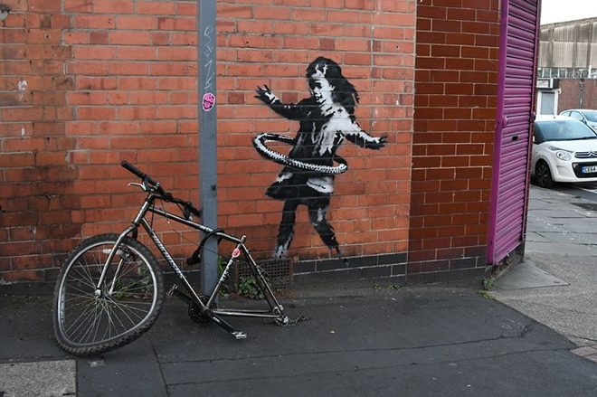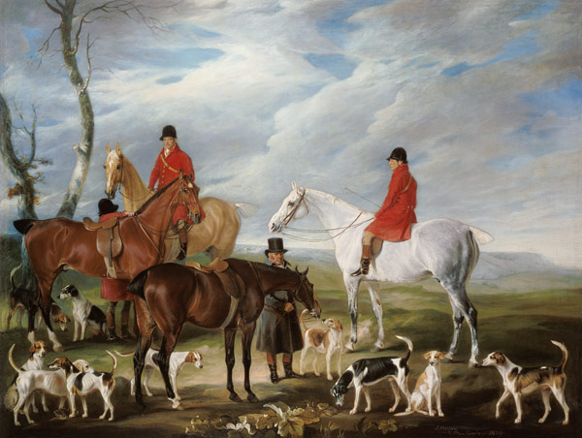
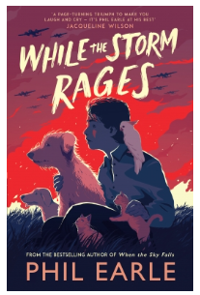

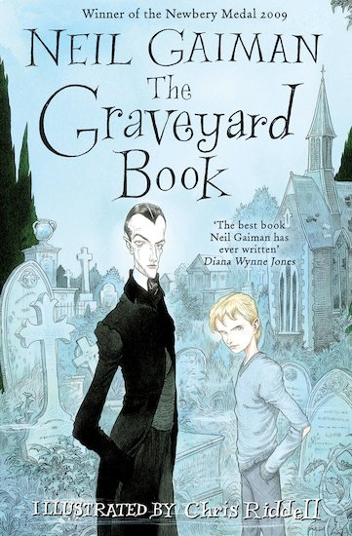
When a tiny baby escapes a murderer intent on slaying his entire family, who would have thought he would find safety in the local graveyard?
Brought up by the cemetery’s resident ghosts, ghouls and spectres, Bod has an eccentric childhood learning about life from the dead. But the killer is still on his trail, and danger is coming, not from the dead but from the living…
Written by Neil Gaiman, author of Coraline, and illustrated by Chris Riddell, this intricate and deliciously creepy Gothic fantasy tells the story of Bod’s life from babyhood to adolescence. Will he survive to be a man?
Winner of the Carnegie Medal 2010 and the ALA Newbery Medal.

Biography – Everest: The Remarkable Story of Edmund Hillary and Tenzing Norgay – by Alexandra Stewart and Joe Todd-Stanton
In addition, linked to our Design and Technology work, we will advertise our product using persuasive writing.
Our Class Book:
The Graveyard Book by Neil Gaman

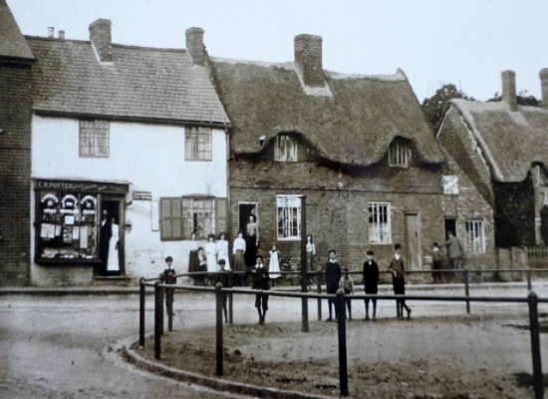

Maths
Year 5:
Perimeter and Area
Step 1 Perimeter of rectangles Step 2 Perimeter of rectilinear shapes Step 3 Perimeter of polygons Step 4 Area of rectangles Step 5 Area of compound shapes Step 6 Estimate area
Statistics
Step 1 Draw line graphs Step 2 Read and interpret line graphs Step 3 Read and interpret tables Step 4 Two-way tables Step 5 Read and interpret timetables
Shape (will continue after Easter)
Step 1 Identify angles Step 2 Compare and order angles Step 3 Measure angles in degrees Step 4 Measuring with a protractor Step 5 Drawing lines and angles accurately Step 6 Calculating angles on a straight line Step 7 Calculating angles around a point Step 8 Triangles Step 9 Quadrilaterals Step 10 Calculating lengths and angles in shapes Step 11 Regular and irregular polygons Step 12 Reasoning about 3-D shapes
Year 6
Perimeter, Area and Volume
Step 1 Shapes – same area Step 2 Area and perimeter Step 3 Area of a triangle – counting squares Step 4 Area of a right-angled triangle Step 5 Area of any triangle Step 6 Area of a parallelogram Step 7 Volume – counting cubes Step 8 Volume of a cuboid
Statistics
Step 1 Line graphs Step 2 Dual bar charts Step 3 Read and interpret pie charts Step 4 Pie charts with percentages Step 5 Draw pie charts Step 6 The mean
Shape ( will continue after Easter)
Step 1 Measure with a protractor Draw lines and angles accurately Step 2 Angles on a straight line Step 3 Angles around a point Step 4 Calculate angles Step 5 Vertically opposite angles Step 6 Angles in a triangle Angles in a triangle Step 7 Angles in special quadrilaterals Step 8 Angles in regular polygons Step 9 Draw shapes accurately Step 10 Draw nets of 3-D shapes
English
Fiction – Narrative-a bildungsroman – a story about a character’s formative years (their growing-up years) Text: The Graveyard Book by Neil Gaman
Lessons concentrate on the teaching of writing with a sharp focus on the craft and construction of sentences. Each Sentence Stacking lesson is organised into three learning chunks which incorporate effective punctuation and grammar alongside use of ambitious vocabulary and figurative language. This Sentence Stack will build over the duration of the unit to the culmination of the whole piece of text.
Spelling – The children will all do daily spelling work which is introduced on Monday and tested on Friday. Each day, we will work together as a class on learning about spelling rules, word meanings and helpful ways to remember spellings.
Guided Reading – In small groups, the children take part in a weekly reading session where they share a book and study it in depth alongside the teacher or teaching assistant.
Handwriting – Our handwriting work will also incorporate an element of grammar and punctuation from our English work to re-enforce prior learning.

Subject and National Curriculum Reference | Key Knowledge
Science - Light  National Curriculum Ref.  Pupils should be taught to:  -recognise that light appears to travel in straight lines  - use the idea that light travels in straight lines to explain that objects are seen  because they give out or reflect light into the eye  -explain that we see things because light travels from light sources to our eyes or  from light sources to objects and then to our eyes  -use the idea that light travels in straight lines to explain why shadows have the same  shape as the objects that cast them. | Pupils should build on the work on light in year 3, exploring the way that light behaves, including light sources, reflection and shadows. They should talk about what happens and make predictions.  Pupils might work scientifically by: deciding where to place rear-view mirrors on cars; designing and making a periscope and using the idea that light appears to travel in straight lines to explain how it works.  They might investigate the relationship between light sources, objects and shadows by using shadow puppets. They could extend their experience of light by looking a range of phenomena including rainbows, colours on soap bubbles, objects looking bent in water and coloured filters (they do not need to explain why these phenomena occur).
Religious Education – Why is the Torah so important for Jewish people?  New Agreed Syllabus | - Identify and explain Jewish beliefs about God; Give examples of some texts that say what God is like and explain how Jewish people interpret them  - Make clear connections between Jewish beliefs about the Torah and how Jews use and treat it; make connections between Jewish commandments and how Jews live; Give evidence and examples of how Jewish people put their beliefs into practice  - Make connections between Jewish beliefs studied and how and why they are important to Jewish people today  - Consider and weigh up the value of tradition, ritual, communities, study and worship in the lives of Jews today, and articulate responses on how far they are valuable to peoole who are not Jewish.
Computer Science – Communication – National Curriculum reference:  - - Understand computer networks, including the internet; how they can provide multiple services, such as the World Wide Web, and the opportunities they offer for communication and collaboration  - Select, use and combine a variety of software (including internet services) on a range of digital devices to design and create a range of programs, systems and content that accomplish given goals, including collecting, analysing, evaluating and presenting data and information  - Use technology safely, respectfully and responsibly; recognise acceptable/unacceptable behaviour; identify a range of ways to report concerns about content and contact | We will:  In this unit learners explore how data is transferred over the internet.  Learners initially focus on addressing, before they move on to the makeup and structure of data packets.  Learners then look at how the internet facilitates online communication and collaboration; they complete shared projects online and evaluate different methods of communication.  Finally, they learn how to communicate responsibly by considering what should and should not be shared on the internet.
French – Le transport– National curriculum reference:  - engage in conversations; ask and answer questions; express opinions and respond to those of others; seek clarification and help reading aloud or using familiar words and phrases  - read carefully and show understanding of words, phrases and simple writing  - broaden their vocabulary and develop their ability to understand new words that are introduced into familiar written material, including through using a dictionary  - write phrases from memory, and adapt these to create new sentences, to express ideas clearly  - describe people, places, things and actions orally and in writing  - understand basic grammar appropriate to the language being studied, including (where relevant): feminine, masculine and neuter forms and the conjugation of high-frequency verbs; key features and patterns of the language; how to apply these, for instance, to build sentences; and how these differ from or are similar to English | We will:  - Talk about forms of transport  - Ask and talk about where you’re going and how you’re getting there  - Talk about plans for a trip  - Buy tickets at the station
PSHE –  Relationships Education: Being Safe (BS)  • how to respond safely and appropriately to adults they may encounter who they do not know. (This is also addressed in PS 3/4 Personal Safety.)  This unit also contains teaching which directly addresses the requirements for: Health Education: Health and Prevention (HP)  • about safe and unsafe exposure to the sun, and how to reduce the risk of sun damage, including skin cancer. Basic First Aid (BFA)  • know how to make a clear and efficient call to emergency services if necessary. (This is also addressed in PS 3/4 Personal Safety.)  • concepts of basic first-aid, for example dealing with common injuries, including head injuries.  This unit also contributes towards the following elements of the statutory requirements in Health Education: Mental Wellbeing (MW)  • the benefits of physical exercise, time outdoors, community participation, voluntary and service-based activity on mental wellbeing and happiness.  • how to recognise and talk about their emotions, including having a varied vocabulary of words to use when talking about their own and others’ feelings.  • how to judge whether what they are feeling and how they are behaving is appropriate and proportionate. | At the end of this unit most pupils will:  • describe some benefits and consequences of taking risks, in familiar and unfamiliar contexts  • describe ways their levels of responsibility are changing  • describe strategies for getting help from known and unknown adults, even when this is difficult  • describe strategies for staying safer on the roads when using them independently, as a cyclist or pedestrian  • describe strategies to keep safer in the sun  • describe some first aid procedures to be used in familiar and unfamiliar situations.
P.E. Athletics  Pupils should be taught to:  - use running, jumping, throwing and catching in isolation and in combination  -develop flexibility, strength, technique, control and balance [for example, through  athletics and gymnastics] | Swimming – over the year the aim is that pupils can:  swim competently, confidently and proficiently over a distance of at least 25 metres; use a range of strokes effectively [for example, front crawl, backstroke and breaststroke]; perform safe self-rescue in different water-based situations.
Music –

