**History**

National Curriculum Ref. *Pupils should be taught about:*

*changes within living memory.*

*events beyond living memory that are significant nationally or globally*

*the lives of significant individuals in the past who have contributed to national and international achievements. for example, Neil Armstrong, …*

We will learn about:

* Flight and Space pioneers
* The space race
* the 1969 moon landing

**Design and Technology**

National Curriculum Ref. –

*generate, develop, model and communicate their ideas through discussion, annotated sketches, cross-sectional and exploded diagrams and prototypes.*

***Make***

*select from and use a wider range of tools and equipment to perform practical tasks [for example, cutting, shaping, joining and finishing], accurately*

*select from and use a wider range of materials and components, including construction materials, and electrical components, according to their functional properties and aesthetic qualities*

***Evaluate***

*evaluate their ideas and products against their own design criteria and consider the views of others to improve their work*

***Technical knowledge***

*understand and use mechanical systems in their products [for example, gears, pulleys, cams, levers and linkages]*

We will:

* Find out all about the Mars Curiosity Rover.
* Make our own motorised models of the Mars rover and evaluate its performance on different surfaces.
* create a circuit which will power their vehicle
* Make improvements to overcome problems.

**Journey Into Space!**

Year 5 and 6 Topic Web – Autumn 2 - 2021

**English**

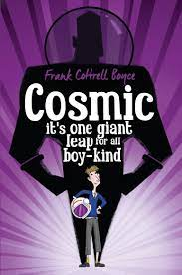

**Science Fiction - Cosmic by Frank Cottrell Boyce**

We will also study the features of non-fiction explanations in order to write our own explanations about telescopes, missions to Mars and the solar system.

We will:

* use a colon to introduce a list and to punctuate bullet points accurately,
* plan and write an information text using organisational and presentational devices to structure it,
* plan and write a persuasive letter learning about persuasive devices and

formality,

* evaluate our writing: proof reading, editing and making improvements where necessary.

**Computing**

National Curriculum Ref. *design, write and debug programs that accomplish specific goals, including controlling or simulating physical systems; solve problems by decomposing them into smaller parts*

*use sequence, selection, and repetition in programs; work with variables and various forms of input and output*

*use logical reasoning to explain how some simple algorithms work and to detect and correct errors in algorithms and programs*

We will:

* Programming -Design and make a ‘space invaders’ game

**Science is also part of this topic – see on page 2**

**Science**

National Curriculum Ref. *Pupils should be taught to:*

* *describe the movement of the Earth and other planets relative to the sun in the solar system*
* *describe the movement of the moon relative to the Earth*
* *describe the sun, Earth and moon as approximately spherical bodies*
* *use the idea of the Earth’s rotation to explain day and night and the apparent movement of the sun across the sky*

We will:

* be introduced to a model of the sun and Earth that enables them to explain day and night. We will learn that the sun is a star at the centre of our solar system and that it has 8 planets: Mercury, Venus, Earth, Mars, Jupiter, Saturn, Uranus and Neptune (Pluto was reclassified as a ‘dwarf planet’ in 2006). We will learn that a moon is a celestial body that orbits a planet (Earth has 1 moon; Jupiter has 4 large moons and numerous smaller ones).
* find out about the way that ideas about the solar system have developed, understanding how the geocentric model of the solar system gave way to the heliocentric model by considering the work of scientists such as Ptolemy, Alhazen and Copernicus.
* work scientifically by: comparing the time of day at different places on the Earth through internet links and direct communication; creating simple models of the solar system; constructing simple shadow clocks and sundials, calibrated to show midday and the start and end of the school day.



|  |
| --- |
| **Maths**  **Four Number Operations continued**  **Year 5:** Identify multiples, factors and prime numbers / multiply up to 4 digit numbers by a one or two-digit number / divide up to 4 digit numbers by a one digit number using short division and interpret remainders correctly/ multiply and divide numbers including decimals by 10, 100 and 1000 / recognise and use square numbers  **Year 6:** Use long multiplication and long division to multiply or divide four digit numbers by a two-digit whole number, interpreting remainders correctly / identify common factors, common multiples and prime numbers / solve multi-step problems in contexts deciding which operations and methods to use and why  **Fractions**  **Year 5**: identify equivalent fractions, convert improper fractions to mixed numbers, compare and order fractions less than one and greater than one, add and subtract fractions, multiply fractions by an integer, calculate fractions of a quantity and amount, solve problems about fractions.  **Year 6**: identify equivalent fractions, simplify fractions, convert improper fractions to mixed numbers and vice versa, compare and order fractions and place fractions on a number line, add and subtract fractions including improper fractions and those with different denominators, multiply fractions by integers, multiply fractions by fractions, divide fractions by integers, find fractions of amounts, use all four operations to solve problems involving fractions. |

|  |  |
| --- | --- |
| **Subject and National Curriculum Reference** | **Key Knowledge** |
| **Religious Education – What do religions say to us when life gets hard? (Agreed Syllabus)** | * Express ideas about how and why religion can help believers when times are hard, giving examples •Outline Christian, Hindu and/or nonreligious beliefs about life after death •Explain some similarities and differences between beliefs about life after death •Explain some reasons why Christians and Humanists have different ideas about an afterlife. * Give reasons why some people might be comforted by their beliefs when someone dies •Describe the impact that the belief that we have a soul might have on the way someone might live their life •Describe the Hindu belief in reincarnation and Karma •Describe a link between a reading that might be used at a funeral and a Christian belief about life after death |
| **French – À l’école**   * Listen attentively to spoken language and show understanding through responding * Engage in conversations; ask and answer questions; express opinions and respond to those of others * Understand basic grammar appropriate to the language being studied | * Name school subjects * Talk about likes and dislikes at school * Ask and say the time * Talk about the timings of the school day * Learn about similarities between English and French schools |
| **PSHE – My emotions Anti-bullying**  (Statutory requirements for Relationships Education)  •know that healthy friendships are positive and welcoming towards others, and do not make others feel lonely or excluded.  • how to recognise who to trust and who not to trust, how to judge when a friendship is making them feel unhappy or uncomfortable, managing conflict, how to manage these situations and how to seek help or advice from others, if needed.  • that most friendships have ups and downs, and that these can often be worked through so that the friendship is repaired or even strengthened, and that resorting to violence is never right.  • the importance of respecting others, even when they are very different from them (for example, physically, in character, personality or backgrounds), or make different choices or have different preferences or beliefs  • about different types of bullying (including cyberbullying), the impact of bullying, responsibilities of bystanders (primarily reporting bullying to an adult) and how to get help.  • that in school and in wider society they can expect to be treated with respect by others, and that in turn they should show due respect to others, | * be able to describe the key characteristics and forms of bullying * be able to talk about personal reasons why someone may engage in bullying * be beginning to identify and describe specific types of prejudice driven bullying * be able to describe the different roles of those involved in a bullying situation * be able to describe how peer pressure affects a situation, and demonstrate simple strategies to intervene in a bullying situation and defend a person who is being bullied * be able to describe confidently and demonstrate a number of assertiveness techniques * be beginning to identify places where bullying may take place in the community. |
| **P.E. Gymnastics / Invasion Games**   * use running, jumping, throwing and catching in isolation and in combination * play competitive games and apply basic principles suitable for attacking and defending * develop flexibility, strength, technique, control and balance [for example, through athletics and gymnastics] * compare their performances with previous ones and demonstrate improvement to achieve their personal best. | **Gymnastics**   * Develop controlled movements in isolation and as part of a sequence * Work independently and as a pair to plan and execute a series of moves * Develop movement at different levels e.g. floor, bench and box   **Invasion Games**   * An invasion game is used to describe any game where the objective is to attack the opposition's territory and score a goal or point. They are usually played between teams of equal players and these fast-paced games focus on teamwork, maintaining possession, scoring and defending. |
| **Music – Voice**   * play and perform in solo and ensemble contexts, using their voices and playing musical instruments with increasing accuracy, fluency, control and expression * improvise and compose music for a range of purposes using the interrelated dimensions of music * listen with attention to detail and recall sounds with increasing aural memory * use and understand staff and other musical notations * appreciate and understand a wide range of high-quality live and recorded music drawn * from different traditions and from great composers and musicians * develop an understanding of the history of music. | * In this unit, children will learn about the power of their voice; creating and using different sounds in different contexts. Children will interpret, practise and perform graphic scores using a variety of vocal sounds. They will learn about musical notation and match it to audio tracks. They will also combine sounds to create class and group compositions. The unit culminates in groups creating a piece of music using Zum Gali Gali phrases, beat boxing and a backing track. |

**Journey Into Space! - Homework Tasks**

**Please choose a minimum of two of the following tasks** which are linked to our topic. You are welcome to do more than two if you wish. **This work is due to be handed in on Monday 6th December**. You can hand the homework in as follows: by emailing it to [class3@thrussington.leics.sch.uk](mailto:class3@thrussington.leics.sch.uk) or by physically bringing it in. Towards the end of the topic, we will have a Space Day to celebrate our learning and parents will be invited to see what we have been doing at school and at home.

Meteor Craters!

Fill a shallow container with sand or earth (or you could use flour) and smooth the surface. Hold a marble above the tray, let it go and watch it fall and make a crater in the sand. Try it again, dropping the marble from higher up, or using a different sized marble. Use a ruler to measure the sizes of the craters you have made

What happens to the size and shape of the craters if you change the size of the marble? What about when you drop the marble from different heights? What if you use other small round objects? When and how did the craters on the Moon form? Do they have names? Are there any craters on Earth?

Think about how you will present your findings.

Create a moving model of our solar system

Since Ancient Greek times, humans have been mapping the stars and planets. An ancient Greek called Ptolemy was the first philosopher to try to build a model to show how the planets, stars and moons move in relation to each other. He placed the Earth at the centre of his model. Since then, Scientists have disproven Ptolemy’s theory and we now use a Heliocentric model (where the sun is at the centre). Can you use every day objects to create your own model? You could video your model to show how everything moves. Think about how large each object should be in relation to the other too.

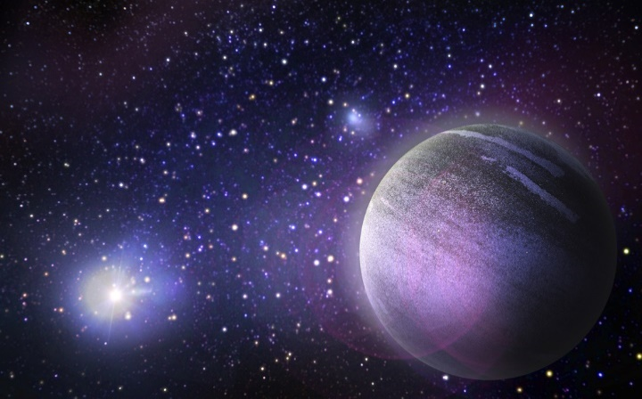

Make a game

Can you use your art and design skills to make a game which will help children to learn about the solar system. You could make a board game, a card game or a quiz. You could even make an online quiz which we could all have a go at answering on our Space Day.

Be a poet!

On a clear night, go outside and look up into the night’s sky. Write a poem about the wonders of space. Remember that poems don’t have to rhyme but they usually include lots of figurative language. Think about how you might illustrate your poem too.

Join NASA Kids’ Club

For more information, go to <https://www.nasa.gov/kidsclub/index.html> Keep a record of activities that you do or things that you find out. You could use screenshots for this.

Greece has all sorts of delicious foods and meals for which it is famous. Have a look at this website for some inspiration: <https://www.family-travel-scoop.com/greek-food-for-kids.html>

Can you make a meal for your family and take a photograph of the end result? It could be a simple Greek breakfast or a sweet treat or, you could try something more adventurous. The choice is yours.