Art, Design and Technology
National Curriculum Ref.
-select from and use a wider range of tools and equipment to perform practical tasks [for example, cutting, shaping, joining and finishing], accurately
- select from and use a wider range of materials and components, including construction materials, textiles and ingredients, according to their functional properties and aesthetic qualities
- to improve their mastery of art and design techniques, including drawing, painting and sculpture with a range of materials [for example, pencil, charcoal, paint, clay]
-about great artists, architects and designers in history.
This half-term, our Art, Design and Technology will all be towards our end of year celebrations including making scenery and props for our school production.
We will also be using mixed media to create seascapes to accompany our work about Captain James Cook.
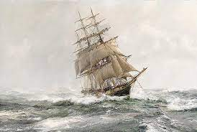
History
National Curriculum Ref. Pupils should be taught to:
Pupils should extend their knowledge with a study of an aspect or theme in British history that extends pupils’ chronological knowledge beyond 1066-
In this Unit, we will:
-learn about Captain James Cook, a famous seafarer, navigator and cartographer. We will also develop our map skills by identifying the routes that he took and learning about the maps that he created in the 1700s.

Important dates for Class Three
Monday 5th June | BACK TO SCHOOL
Wednesday 14th June | Science Fair – Parents invited from 2pm  Girls’ Football tournament Y5/6
Wednesday 21st June | Tennis coaching for all classes  Girls’ Football tournament Y5/6
Friday 23rd June | Philippines Day
Wednesday 28th June | Girls’ Football tournament Y5/6
Monday 3rd July | Sports Day – Parents welcome from 1:30pm
Tuesday 4th July | Class 3 Performance 1:30pm and 6pm
Tuesday 11th July | Year 6 Leaver’s evening 5-7pm Parents welcome from 6:30pm
Wednesday 12th July | Leaver’s church service (school only)  END OF TERM

All at Sea!
Year 5 and 6 Topic Web – Summer 2 - 2023

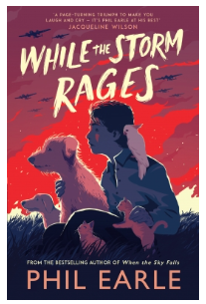

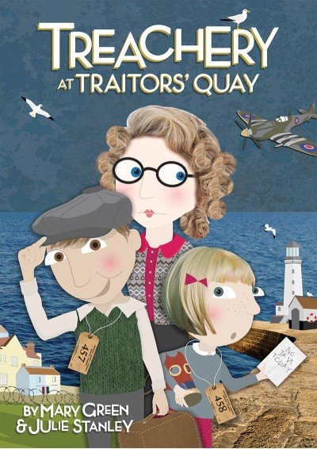
Our big production at the end of this term is Treachery at Traitor’s Quay. Through working on the script together, the children will learn about how to read, understand and perform from a real playscript.

Maths
Year 5:
Negative Numbers
Step 1 Understand negative numbers Step 2 Count through zero in 1s Step 3 Count through zero in multiples Step 4 Compare and order negative numbers Step 5 Find the difference
Converting Units of Measurement
Step 1 Kilograms and kilometres Step 2 Millimetres and millilitres Step 3 Convert units of length Step 4 Convert between metric and imperial units Step 5 Convert units of time Step 6 Calculate with timetables
Measuring Volume
Step 1 Cubic centimetres Step 2 Compare volume Step 3 Estimate volume Step 4 Estimate capacity

Year 6
Consolidation through investigation and exploration
This could be a revision lesson on a particular area of Maths such as measuring angles followed by another lesson in which the children use their learning to solve problems or to investigate a statement.

English
Poetry – using an extended metaphor – Text: The Sea by James Reeves
Lessons will focus on studying The Sea by James Reeves, analysing the poetic devices used. We will demonstrate our understanding of this poem through our artwork before moving on to write our own poems using either metaphors or similes.
Spelling – The children will all do daily spelling work which is introduced on Monday and tested on Friday. Each day, we will work together as a class on learning about spelling rules, word meanings and helpful ways to remember spellings.
Guided Reading – In small groups, the children take part in a weekly reading session where they share a book and study it in depth alongside the teacher or teaching assistant.
Handwriting – Our handwriting work will also incorporate an element of grammar and punctuation from our English work to re-enforce prior learning.
In addition, our Year Six children will be writing their speeches which they will read out to their parents at the Year 6 Leaver’s evening.

Subject and National Curriculum Reference | Key Knowledge
Science -  National Curriculum Ref.  Pupils should be taught to:  use the following practical scientific methods, processes and skills through the teaching of the programme of study content:  - planning different types of scientific enquiries to answer questions, including  recognising and controlling variables where necessary  - taking measurements, using a range of scientific equipment, with increasing  accuracy and precision, taking repeat readings when appropriate  - recording data and results of increasing complexity using scientific diagrams and  labels, classification keys, tables, scatter graphs, bar and line graphs  - using test results to make predictions to set up further comparative and fair tests  - reporting and presenting findings from enquiries, including conclusions, causal  relationships and explanations of and degree of trust in results, in oral and written  forms such as displays and other presentations  - identifying scientific evidence that has been used to support or refute ideas or  arguments. | In this final half-term, the children will be recapping their work from this year.  Look out for our Science fair which takes place on Wednesday 14th June. In the morning, the children will be carrying out STEM investigations in their own classrooms and then in the afternoon, each year group will have been given a scientific challenge to carry out at home and parents will be invited to come and see our tests of their projects at 2pm.
Religious Education – What matters most to humanists and Christians?  Agreed Syllabus | Pupils will:  -identify and explain beliefs about why people are good and bad  -Make links with sources of authority that tell people how to be good  -Make clear connections between Christian and Humanist ideas about being good and how people live  -Suggest reasons why it might be helpful to follow a moral code and why it might be difficult  -Raise questions and suggest answers about how and why people should be good  Make connections between the values studied and their own lives
Computer Science – Creating Media – web page creation National Curriculum reference:  - Use search technologies effectively, appreciate how results are selected and ranked, and be discerning in evaluating digital content  - Select, use, and combine a variety of software (including internet services) on a range of digital devices to design and create a range of programs, systems, and content that accomplish given goals, including collecting, analysing, evaluating, and presenting data and information.  - use technology safely, respectfully, and responsibly; recognise acceptable/unacceptable behaviour. | We will:  This unit introduces learners to the creation of websites for a chosen purpose. Learners identify what makes a good web page and use this information to design and evaluate their own website using Google Sites. Throughout the process learners pay specific attention to copyright and fair use of media, the aesthetics of the site, and navigation paths.
French – On va faire la fête National curriculum reference:  - engage in conversations; ask and answer questions; express opinions and respond to those of others; seek clarification and help reading aloud or using familiar words and phrases  - read carefully and show understanding of words, phrases and simple writing  - broaden their vocabulary and develop their ability to understand new words that are introduced into familiar written material, including through using a dictionary  - write phrases from memory, and adapt these to create new sentences, to express ideas clearly  - describe people, places, things and actions orally and in writing  - understand basic grammar appropriate to the language being studied, including (where relevant): feminine, masculine and neuter forms and the conjugation of high-frequency verbs; key features and patterns of the language; how to apply these, for instance, to build sentences; and how these differ from or are similar to English | We will:  - Put our learning from this year into practice through a French celebration with food, music, games and dance.
PSHE – Healthy Lifestyles  In September 2020, the DfE introduced statutory requirements for Relationships Education and Health Education which are to be covered by the end of Primary School. This unit contains teaching which directly addresses the requirements for Relationships Education:  - Mental Wellbeing  - Internet Safety & Harms  - Physical Health and Fitness  - Healthy Eating  - Health and Prevention | We will explore:  - How does physical activity help me and what might be the risks of not engaging in it  - What are the characteristics of a balanced / unbalanced diet  - What are different aspects of a healthy lifestyle and how could a person become healthier  - What might the signs of physical illness be and how could we respond  - What might be signs of mental illness and how could we respond  - What are the benefits and risks of spending time online and why are online apps and games age restricted?
P.E. Rounders  Pupils should be taught to:  - use running, jumping, throwing and catching in isolation and in combination ♣ play competitive games, modified where appropriate [for example, badminton, basketball, cricket, football, hockey, netball, rounders and tennis], and apply basic principles suitable for attacking and defending | Volleyball:  In our volleyball lessons, the children will learn the skills of volleyball and correct terminology of techniques such as spike, set and dig, before moving on to play games in small teams.  See cricket for National Curriculum links.
Music – Our music this half-term will be centred around preparing for our performance of Treachery at Traitors’ Quay | - We will develop our singing skills and sing to a live audience.

