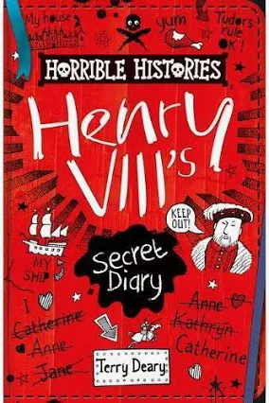
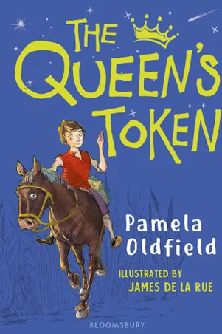
Our Class books:

Terrible Tudors

Year 3 and 4 Topic Web – Autumn Term 1 2022

 | Subjects related to the topic
English -  writing/grammar  Traditional tale  Nouns  Adjectives  Expanded noun phrases  Punctuating direct speech | - Plan, write and edit their own traditional tale based on the story of the Princess and the Pea by Lauren Child.  - Punctuation and Grammar – Demarcate sentences with capital letters, full stops, question and exclamation marks. Use of expanded noun phrases to describe and specify. Use of inverted commas for speech, use of commas after fronted adverbials and capital letters for proper nouns.  - Handwriting - Use the diagonal and horizontal strokes needed to join letters and know which letters are best left un-joined when adjacent
History  The Tudors | - Know about an aspect or theme in British history which extends beyond 1066 and explain why this was important in relation to British history.  - Know about a period of history that has strong connections to their locality and understand the issues associated with the period.  - Know how to learn more about a historical period through asking relevant questions  - Know how to ask questions about artefacts / sources of information to question the validity and reliability of these.
Geography | - Know where important local places are that are linked to the Tudors: Leicester, Bosworth, Bradgate Park.
Art | - Sculpting a 3D model of a Tudor rose from clay. Make a slip to join pieces of clay. Use pinch techniques. Care for sculpting tools and secure materials for continued use at a later date.  - Use mixed media to sketch and then paint a royal portrait in the style of Tudor artists. Experiment with different techniques including blocking in colour, washes, thickened paint. Begin to work in the style of an artist. Use a sketchbook to record media explorations as well as planning and collecting source material for future works.

 | Other areas of the curriculum – not related to the topic
Maths  Place Value  Addition and Subtraction | Year 3 – To represent, partition, order and compare numbers to 1000 using a variety of different representations including the number line.  - To count in 50s  - To add 1s, 10s and 100s to a 3-digit number  - To add and subtract 3 digit numbers including the use of exchange and formal written methods  Year 4 – To represent, partition, order and compare numbers to 10,000 using a variety of different representations including the number line.  - To use Roman numerals  - To round numbers to 10,000  - To add 1s, 10,s 100s, and 1000s to a 4-digit number  - To add and subtract 4 digit numbers including the use of exchange and formal written methods.
Science  Forces and Magnets | We will:  - Know that a force can be thought of as a push or a pull.  - Know that there are three types of contact force: impact forces (when two surfaces collide), frictional forces (when two surfaces are already in contact) and strain forces (when an elastic material is stretched or squashed).  - Know that objects move differently on rough and smooth surfaces; objects resist movement more on rough surfaces because there is higher friction as the object moves.  - Know that there are also non-contact forces that can act between objects without them touching and that magnetism is an example of a non-contact force Know that magnets have two poles called north and south.  - Know that like poles (south-south and north-north) of two magnets repel each other and that opposite poles of two magnets (north-south) attract each other.  - Know that there is a magnetic field around a magnet which is strongest at each pole.  - Know that some materials are magnetic, meaning that they are attracted to a magnet, while other materials are non-magnetic.
RE –  Understanding Christianity – Incarnation/God What is the Trinity? | We will  - Identify the difference between a ‘Gospel’, which tells the story of the life and teaching of Jesus, and a letter.  - Offer suggestions about what texts about baptism and Trinity might mean.  - Describe how Christians show their beliefs about God the Trinity in worship (in baptism and prayer, for example) and in the way they live.  - Make links between some Bible texts studied and the idea of God in Christianity, expressing clearly some ideas of their own about what the God of Christianity is like.  - Give examples of what these texts mean to some Christians today.
PSHE –  Citizenship  Rights, Rules & Responsibilities | We will:  - Be able to explain the difference between wants and needs.  - Be able to explain why rights are important and that they come with responsibilities, at home and at school.  - Be able to express how it feels to be treated with respect and demonstrate how to show respect for others, including those in positions of authority.  - Be able to explain why rules are needed and be able to identify those which are necessary and useful.  - Participate in making class ground rules and show or explain what following the rules looks like.  - Suggest different ways of making a decision and ways they can influence decision making in school, through simple debating and voting.  - Be able to describe what a representative does.
Computing  Branching databases | We will:  - Create questions with yes/no answers and use these to create two groups of objects separated by a single attribute.  - Select and group objects to create and test a branching database.  - Explain why it is helpful for a database to be well structured.  - Plan the structure of a branching database.  - Independently create a branching identification tool.
PE | We will:
French  Bonjour! | We will practise:  - Saying hello and goodbye.  - Asking and saying your name.  - Asking and saying how you are.  - Knowing the names of Musical instruments.  - Learning, using and reciting numbers 1-10
Music –  Pulse | We will:  - Learn about ostinatos and the importance of maintaining a steady pulse when performing the ostinatos.  - Explore and create a range of sounds to compose our own short rhythm to be used as an ostinato.  - Practise our ostinatos and use them in a whole class performance where several rhythmic patterns are being played at once.  - Visual cues will be explained, created and used to conduct groups during their performances.

