Our Class books:
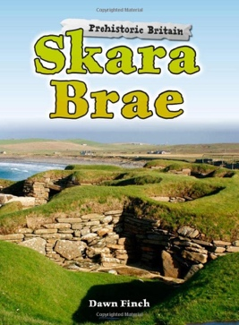
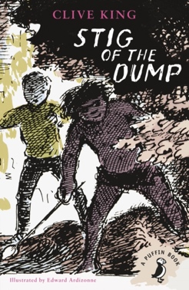

Savage Stone Age

Year 3 and 4 Topic Web – Spring Term 1 2023

 | Subjects related to the topic
English -  writing | - Persuasive holiday brochure – Skara Brae. Our writing focus will be persuasive writing, working towards an independent write of a persuasive leaflet based upon our class trip to Cresswell Crags.  - Instructional writing – How to wash a woolly mammoth. We will study this text before writing instructions for making Stone Age cheese.
History | - We will be exploring the Stone Age looking at what cave men/women were really like and discover what it would have been like to live in those times. We will use timelines to see when the Stone Age period was and how long it lasted. We will examine the types of homes people used to live in, what they ate and how they farmed. We will learn about their art, culture and beliefs. We will also learn why historical artefacts are important and how we can use them to help us discover information about the past.  - H3.1 know what is meant by Neolithic ‘hunter-gatherers’ and early farmers (e.g. Skara Brae)
Geography | - Locate Skara Brae and Cheddar gorge in the UK.  - G4.1 know the names and locate counties and cities in the UK.
Art | - Cave Art – using natural materials to create paint and draw our own Stone Age paintings of prehistoric animals.

 | Other areas of the curriculum – not related to the topic
Maths | We will learn how to multiply and divide 2-digit numbers by 1-digit numbers, using the formal method of short multiplication and partitioning for division to enable us to calculate outside of the times tables.  We will measure, compare, add and subtract lengths in mm, cm, m and km and measure and calculate the perimeter of simple 2D shapes. In Year 4 we will find the area of rectilinear shapes by counting squares.  We will learn to recognise and explain the similarities and difference between unit and non-unit fractions. We will use number lines to count up and down in fractions, including counting part 1 whole. We will learn to recognise and work with equivalent fractions, spotting patterns and calculating equivalent fractions using proportionality.
Science  Sound | We will:  - identify how sounds are made, associating some of them with something vibrating  - recognise that vibrations from sounds travel through a medium to the ear  - find patterns between the pitch of a sound and features of the object that produced it  - find patterns between the volume of a sound and the strength of the vibrations that produced it.  - recognise that sounds get fainter as the distance from the sound source increases.
RE | How do Festivals and family life show what matters to Jews?  We will explore the importance of family and home in Judaism; what Jews believe and the difference this makes to how they live. We will learn about the Jewish celebrations of the Shabbat, Rosh Hashanah, Yom Kippur, Pesach and why the commandments and blessings are important to Jewish people.
PSHE | Healthy and safer lifestyles – Relationships and sex education  • be able to identify the main stages of the human lifecycle and  identify the stage of an individual with reasonable accuracy  • be able to explain that a baby grows from a male seed and a  female egg  • be able to explain ideas about being grown up and show they  have a relatively realistic view of adulthood  • be able to identify an area for which they can take more  responsibility  • be able to explain some ways that parents/carers are responsible  for babies and understand that these responsibilities are based  on the fact that a baby cannot look after itself.
Computing  Desktop publishing | We will:  - Recognise how text and images communicate information  - Recognise that text and layout can be manipulated  - Learn to choose appropriate page settings  - Learn to add content to a desktop publishing document  - Consider how different layouts can suit different purposes  - Consider the benefits of desktop publishing
PE | Dance  - Understand the context of the dance and applying their knowledge of what they know of Ancient Egypt)  - Demonstrating balance, facial expression, and Shape  - Demonstrating getting into character of a mummy and performing slow movements.  - Using improvisation to show different movements.  - Reflecting and observing others.  - Applying actions and dynamic movements.  - Performing a whole routine from start to finish.  Swimming  - Demonstrating the Breaststroke  - Knowing different water safety scenarios  - Using gliding and kicking skills into games  - Developing the front crawl and the backstroke  - Applying the skills that they have learnt into a aqua-splash festival.
French  Les fêtes | We will:  - Talk about festivals and dates  - Talk about presents at festivals  - Count from 31-60  - Give and understand instructions
Music | Rhythm  In this unit, children will continue to develop composing and performing skills. They will also explore how rhythms can be created by using syllable patterns from simple spoken phrases. Children will experience working in mixed ability groups and creating graphic scores to notate their ideas. The unit will finish with a performance which is recorded, allowing for self and peer assessment.

