Art and Design
Summary of the unit:
The children will explore patterns at home and in the world as well as artists who use patterns. They will use stencils and printing techniques to explore patterns using rotation, symmetry and reflection. The children will be given a particular purpose e.g. a cushion or a shopping bag and they will design and create the fabric for that purpose.
Knowledge and Understanding / Skills
- Use a sketchbook to record media explorations as well as planning and collecting source material for future works.
- Increase awareness of mono and relief printing by using a range of techniques.
- Start to overlay prints with other media.
- Demonstrate experience in fabric printing.
- Interpret environmental and manmade patterns.
- Explore how ICT is used for pattern making e.g. wall paper, fabric etc.
- Make a range of patterns, including tessellation. Become confident in applying colour through printing and tie dye. Begin to use resist paste and batik.

Geography
National Curriculum Ref. L
We will:
- Know that geography is the study of places and the relationships between people and their environments
- Know the names of the seven continents and name on a world map and globe: Europe, North America, South America, Africa, Asia, Australia and Antarctica
- Know the location of the North and South Poles and know that they are the cold parts of the Earth
- Know that there is one global ocean that is often divided into five distinct oceans and locate them on a world map and globe: the Pacific Ocean, the Atlantic Ocean, the Indian Ocean, the Southern Ocean and the Arctic Ocean
- Know that an endangered species is one that is threatened by extinction
- Know that the Amazon River carries more water than any other river on Earth
- Know that a tributary is a smaller river or stream that joins a larger river, adding to its flow
- Know that the Amazon River and its tributaries flow through Peru, Bolivia, Venezuela, Colombia, Ecuador, and Brazil before emptying into the Atlantic Ocean; know how to identify the countries and the Amazon River using an atlas.
- Know that the Amazon rainforest is the largest rainforest on Earth and provides the habitats for the largest variety of plants and animals on the planet; this variety can also be described as biodiversity; part of the reason for this biodiversity is the wet, warm climate that encourages plant growth
- Know that large parts of the Amazon rainforest – like most rainforests across the world – are being cut down for timber and to make way for farming; the current rate equates to an area around 80 times the size of our school field being cut down every minute; know that this process is called deforestation
- Know that deforestation is threatening many animals and plants with extinction, as well as contributing to climate change; ¹/₁₀ of all the world’s species of plants and animals; around ¹/₄ of all modern medicines originated rainforests; there may be many more to be found that won’t be due to deforestation
Rainforest Rescue
Year 3 and 4 Topic Web – Autumn 2 - 2021
English
Our Class Book: The Great Kapok Tree and The Explorer
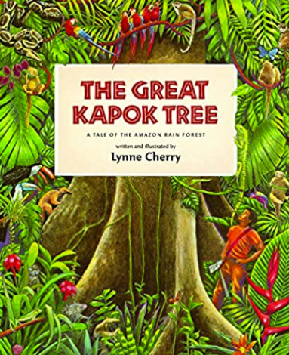
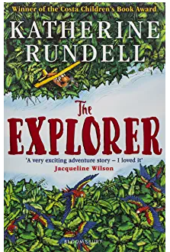
We will also read non-fiction texts to research the Rainforest. We will look at real life documentaries to support knowledge.

We will:
- Write a persuasive poster about saving the rainforest, using emotive language, rhetorical questions, repetition, connectives, persuasive devices and exaggeration.

- Write a Non- Chronological report about an aspect of the Amazon / Rainforest, using paragraphs, subheadings, fact boxes, bullet points, factual language, present tense, third persona and formal tone.

- Know that a rainforest is made up four layers: an emergent layer, which is the uppermost layer (the treetops); a canopy layer, which is a middle layer of closely-growing tree branches and leaves; an understory, which is made up of smaller trees, plants and shrubbery beneath the canopy layer; and the forest floor, the ground level of the rainforest, home to large mammals not suited to climbing
- Know that there are imaginary lines of latitude and longitude on the Earth; know that latitude shows the north/south position of a given location and that longitude shows the east/west position of a given location (see diagram below)
- Know that there are tropics to the north and south of the Equator - the Tropic of Cancer to the north and the Tropic of Capricorn to the south – and that the Amazon rainforest is located in and around the Tropic of Capricorn

Computing -Editing and writing HTML.
Identify web pages they like and use Hackeraurus to see the HTML code for each section.
Plan how they would change the web page to make it relevant to us.
Make changes to the page by changing the HTML code.
Use editing and literacy skills to write grabbing articles.

Science  Living things and their habitats  - Sc4/2.1a recognise that living things can be grouped in a variety of ways  - Sc4/2.1b explore and use classification keys to help group, identify and name a variety of living things in their local and wider environment  - Sc4/2.1c recognise that environments can change and that this can sometimes pose dangers to living things. | New learning and vocabulary  kingdom, classification key, species, fungi, bacteria, climate change, characteristics, offspring, extinction, pollution  Know that animals can be grouped based on their physical characteristics (e.g. vertebrates and invertebrates) and based on their behaviour (e.g. herbivores, carnivores and omnivores)  Know that living things are divided into kingdoms: the animal kingdom, plants, fungi, bacteria, and single-celled organisms  Know that a species is a group of living things have many similarities that can reproduce together produce offspring  Know that a classification key uses questions to sort and identify different living things  Know how to use a classification key to identify living things  Know how to create a classification key to sort plants on the school premises  Know that changes to the environment can make it more difficult for animals to survive and reproduce; in extreme cases this leads to extinction, where an entire species dies  Know that human activity – such as climate change caused by pollution - can change the environment for many living things, endangering their existence  Know that the polar bear is a famous example of climate change endangering the existence of a species; as the climate changes and gets warmer, the sea ice on which polar bears live reduces in amount making it harder for them to survive and reproduce
Other Areas of the Curriculum – not linked to the topic

Maths
Addition/Subtraction
Year 3 - Subtract numbers mentally, including: a three-digit number and ones; a three-digit number and tens; a three- digit number and hundreds. Subtract numbers with up to three digits, using efficient written methods, including formal written methods of columnar subtraction. Estimate the answer to a calculation and use inverse operations to check answers. Solve problems, including missing number problems, using number facts, place value, and more complex addition and subtraction.
Year 4 - Subtract numbers with up to 4 digits using the formal written methods of columnar addition and subtraction where appropriate. Estimate and use inverse operations to check answers to a calculation. Solve addition and subtraction two step problems in contexts, deciding which operations and methods to use and why.
Multiplication/Division
Year 3 – Use arrays, recall and use multiplication and division facts for multiplication tables 2, 5, 10, 3, 4, and 8.
Year 4 - Use arrays, recall and use multiplication and division facts for multiplication tables up to 12 x 12. Multiply by 10, 100 and divide by 10, 100.

Religious Education – Incarnation/God (Understanding Christianity) | Unit Outcomes  Pupils will know that…  - Christians believe Jesus is one of the three persons of the Trinity: God the Father, God the Son and God the Holy Spirit.  - Christians believe the Father creates; he sends the Son who saves his people; the Son sends the Holy Spirit to his followers.  - Christians worship God as Trinity. It is a huge idea to grasp, and Christians have created art to help to express this belief.  - Christians believe the Holy Spirit is God’s power at work in the world and in their lives today, enabling them to follow Jesus.  - Jesus the Son is seen by Christians as revealing what God the Father is like. They believe he promises to stay with them and Bible stories show how God keeps his promises.  - Christians find that understanding God is challenging; people spend their whole lives learning more and more about God.  - Christians really want to try to understand God better and so try to describe God using symbols, similes and metaphors, in song, story, poems and art.
French – Unit 2 Rigolo | Classroom objects, classroom instructions, colours and saying their age.  Children will speak in short sentences, answering questions and using the correct masculine or feminine indefinite article (un, une) for nouns.  Look at the difference in word order within French sentences compared to English sentences.  Develop their speaking skills and reinforce accurate pronunciation.
PSHE –  My Emotions | Why is it important to accept and feel proud of who we are? RR  • What does the word ‘unique’ mean and what do I feel proud of about myself? RR  • Why is mental wellbeing as important as physical wellbeing? MW  • How can I communicate my emotions? MW  • Can I recognise some simple ways to manage difficult emotions? MW  • What does it mean when someone says I am “over reacting” and  how do I show understanding towards myself and others? MW  • How do my actions and feelings affect the way I and others feel? MW  • How do I care for other people’s feelings? MW  • Who can I talk to about the way I feel? MW• How can I disagree without being disagreeable? RR
P.E. Dance and Dodgeball | Dance - The Water Cycle  Create actions and dynamic movements to represent different water features.  Choreograph simple dances, ensuring they dance at different levels and link transitions with appropriate moves.  Develop teamwork skills, spatial awareness, timing skills and working in unison.  Dodgeball  Develop their reactions and movement in dodging in different ways.  Develop catching skills and accuracy in aiming and throwing.  Develop blocking skills in attack and defence.
Music –Ukelele class lessons | - In this unit, children will work in small groups, composing rhythm patterns which are then practised with an emphasis on maintaining pulse. They will explore graphic and formal notation, using crotchets, quavers and rests and compare how these representations can look when placed side by side.

Rainforest Rescue!
Homework Tasks
In your reading diary, it explains the expectations for homework with regards to reading, spelling and maths each week. In addition, I would like you complete one task every 2 weeks, these are linked to our topic. You are welcome to do more if you wish! This work is due to be handed in on Monday 6th December. You can hand the homework in as follows: by emailing it to class2@thrussington.leics.sch.uk; by submitting it on Teams or by physically bringing it in.

Task A  Combine the features of  two animals from the rainforest to create your own  new animal. Make a fact file  about it. What name would  you give it? Which features  did you choose and why?  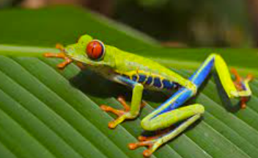 | Task B  Design and make a  rainforest model. What could  you use from our natural/manmade  environment? Think about the  plant layers e.g. shrub layer,  under canopy.  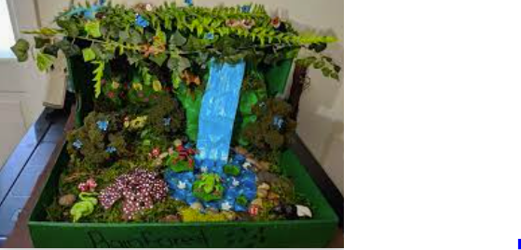 | Task C  Compose and perform a rainforest dance/music. What  music/sounds would fit with  the rainforest theme? What  movements could you do?  Video your performance. | Task D  Create ‘Did you know?’ fact  cards about the rainforest.  Help your class discover  amazing facts. | Task E  Write an imaginative story  about the life of a child surviving in the rainforest. How did they get there? Where will they  end up? What will they see?  Who or what might they be afraid of?  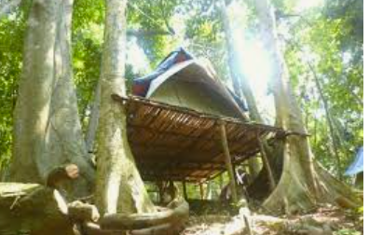
Task F  Find out about a tribe who  live in the  rainforest. Where do they  live? What do they eat? Do  children attend school?  Present your findings using  PowerPoint.  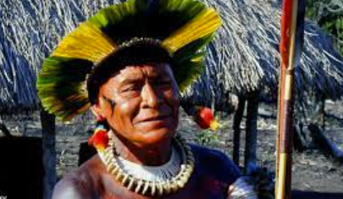 | Task G  An area of rainforest the size  of a football pitch is being  destroyed every second. Create a poster to persuade people to help protect the rainforest.  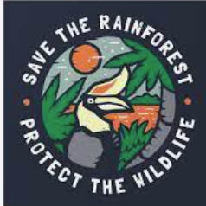 | Task H  Imagine you are an  explorer in the  rainforest. Write a diary  based on the events that had  taken place.  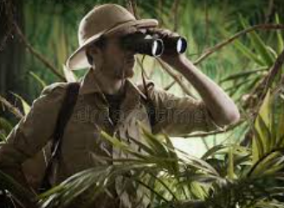 | Task I  Write a formal letter to the  Government to  persuade them to ‘Save our  rainforests’ | Task J  Find out about foods that may grown in the Amazon Rainforest. Can we get any in England?  Taste test and review your findings.  