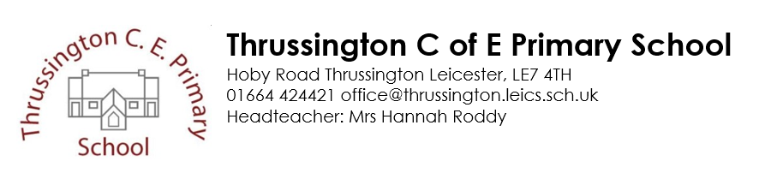
24th May 2021
Dear Parents and carers,
I just wanted to write to outline some of the events we are hoping to hold next term as long as Government guidelines allow.
Science Fair – Tuesday 22nd June 2021
On Friday I will send out the Science Fair pack. Each Year group has a different challenge to attempt at home. Each challenge has a Science curriculum connection and it’s important that your child attempts their challenge with the least amount of adult help as possible – obviously working with them and helping them understand the science behind the challenge would be a huge benefit so please use your judgement!!!
Your child will then bring their project in on Science Fair day (Tuesday 22nd June) The day will be Science themed, with various inputs and investigations throughout the day, culminating in the testing of their projects. If restrictions ease as planned I would like to be able to invite parents on site to witness their child’s Science task being tested outside but again the feasibility of this will be clearer nearer the date.
Class 2 Beaumanor Trip – Tuesday 29th June
Parents will drop their children at Beaumanor Hall at 9:30am and pick up at 4pm. Please pay through Arbor if you have not already done so.
Proms on the Playground – Wednesday 30th June 2021 (5pm)
This is an opportunity for the musical children amongst us to perform to their family and friends. The joy of this event, when I have organised them in the past, is that performances can range from someone early in their music learning playing hot cross buns to a Grade 1/2 piece being performed confidently. It is important to celebrate the hard work that goes into practising regardless of level or stage in their musical journey.
I would like to invite parents to come, bring drinks and nibbles and sit at socially distanced tables to enjoy the performances in a relaxed and hopefully sunny setting. More details will follow.
Class 3 Beaumanor Trip – Friday 2nd July
Parents will drop their children at Beaumanor Hall at 9:30am and pick up at 4pm. Please pay through Arbor if you have not already done so.

Year 6 Leavers’ Service in the church (for children and Governors only to attend) – Wednesday 7th July – 10:30am ( this will be videoed to be shared on the Newsletter)
We will hopefully have an opportunity for the whole school to worship together with Sister Mary, in the Church, to recognise and reflect on our Year 6’s time at Thrussington.
Sports Day – Thursday 8th July – 9:30am
Weather permitting we hope to hold a whole school Sports Day. We are still planning how this will work but plan to have both competitive opportunities and teamwork games through the morning.
Year 6 Leavers’ Evening and speeches - Thursday 8th July – 4:30 - 7 pm
We plan to give our wonderful Year 6 the send-off they deserve! Parents will be invited to join us from 6pm for their speeches (outside).
Last day of term – Friday 9th July

Please note these dates may change/ access to school for parents may not be possible due to any new guidance which may be issued so please read the weekly newsletter for updates.

Many thanks
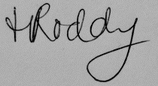
Mrs Roddy
Headteacher

