7.7.21

Dear Parents/Carers,
After yesterday’s guidance I am writing to inform you of the arrangements for the beginning of next term.
P.E. kits
We will keep the same arrangement as we currently have. Children will come into school in P.E. kit on P.E. days.
EYFS – Tuesday, Class 1 – Wednesday and Thursday, Class 2 – Monday and Friday, Class 3 – Thursday and Friday.
Arrival at school (am)
This will be different from pre- COVID times so please read very carefully.
- Gates open at 8:45am
- Children arrive and are taken straight to their classroom door where they will leave their parents/carers to settle to morning work in the classroom.
- Children are not to play on the playground before school, there will be no staff on duty.
- Teachers will be in class with the children so a short message may be able to be passed onto them at the door, if a longer chat is required then please contact your class teacher on the class email and a time can be arranged.
- Gates will be shut at 8:55am for the start of registration and all parents/carers will be required to leave the school grounds.
Pick up (pm)
- Gates will open at 3:10pm
- Parents/carers will wait outside their child’s door to collect their child at 3:15pm.
- Gates will be locked at 3:25pm to ensure the safety of our After School Club children, so please ensure children do not play in our playground after school and that you leave the site in good time.

Reminder of start dates
The first day back is Wednesday 25th August 2021
EYFS – Wednesday 25th – Friday 27th 8:55 – 12:50pm
Tuesday 31st –Friday 3rd 11:50-3:15pm
Monday 6th – Friday 10th 8:55 – 12:50pm
Full – time from Monday 13th September
Meals
Please make final orders for meals using this form. This is for the first 3 weeks of term. If your child is not in KS1 or eligible for Free School Meals you will be invoiced for these meals separately and will pay directly into the school bank account.
Wrap Around Care
The programme for after school clubs is below. Please book onto Breakfast and After School clubs using Arbor.
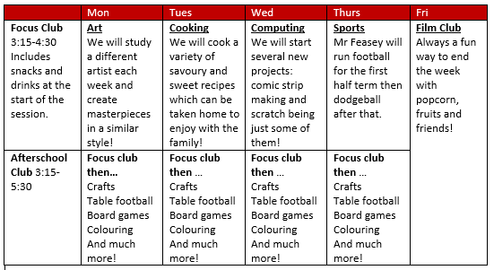
It is looking like our classrooms will be back to pre-COVID times and our children will be able to mix across classes which will be fantastic, especially at playtimes and lunchtimes.
As always if anything changes I will let you know.
Many thanks for your continued support.
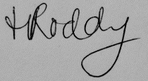
Mrs Roddy
Headteacher

