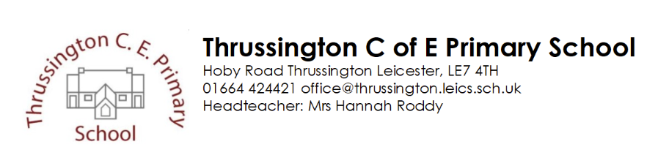
Christmas comes to Thrussington!
Date | Event
Wednesday 1st December | Start of Advent – advent windows decorated
Sunday 5th December | Thrussington Christmas lights switch on – choir to meet Mrs Castilla at 4:55pm on the Green.
Tuesday 7th December | Decorations morning - Children can wear a Christmas jumper or token bit of Christmas sparkle (please don’t go out and buy one especially!)  We will be having a festive morning of Christmas crafts to decorate and prepare the school for a fantastic last few weeks! We hope to be able to invite parents for 45 minute slots during the morning – more details to follow.
Thursday 9th December | Christmas Lunch (please order on the form sent by Mrs Iley), followed by Reindeer (donkey!!!) poop bingo!
Tuesday 14th December | Nativity Play 1:30pm and 6pm (EYFS&KS1) 2 guests per child only at each showing please. Letters for tickets will go out nearer the time.  Deadline for reverse advent calendar offerings
Wednesday 15th December | Whole school Pantomime trip – Aladdin. 9:15am Loughborough Town Hall
Thursday 16th December | Candlelight Carol service in church - KS2 - 5pm ( 2 guests per family please)
Friday17th December | Class parties (children will still need their lunch!)
We are excited to hopefully invite you to join us for some of the events this year. Obviously some events will need to be limited to minimise the Covid risk. These events are open to change depending on Covid circumstance within our community so please look out for updates.

